Ebook Project

Ebook Project

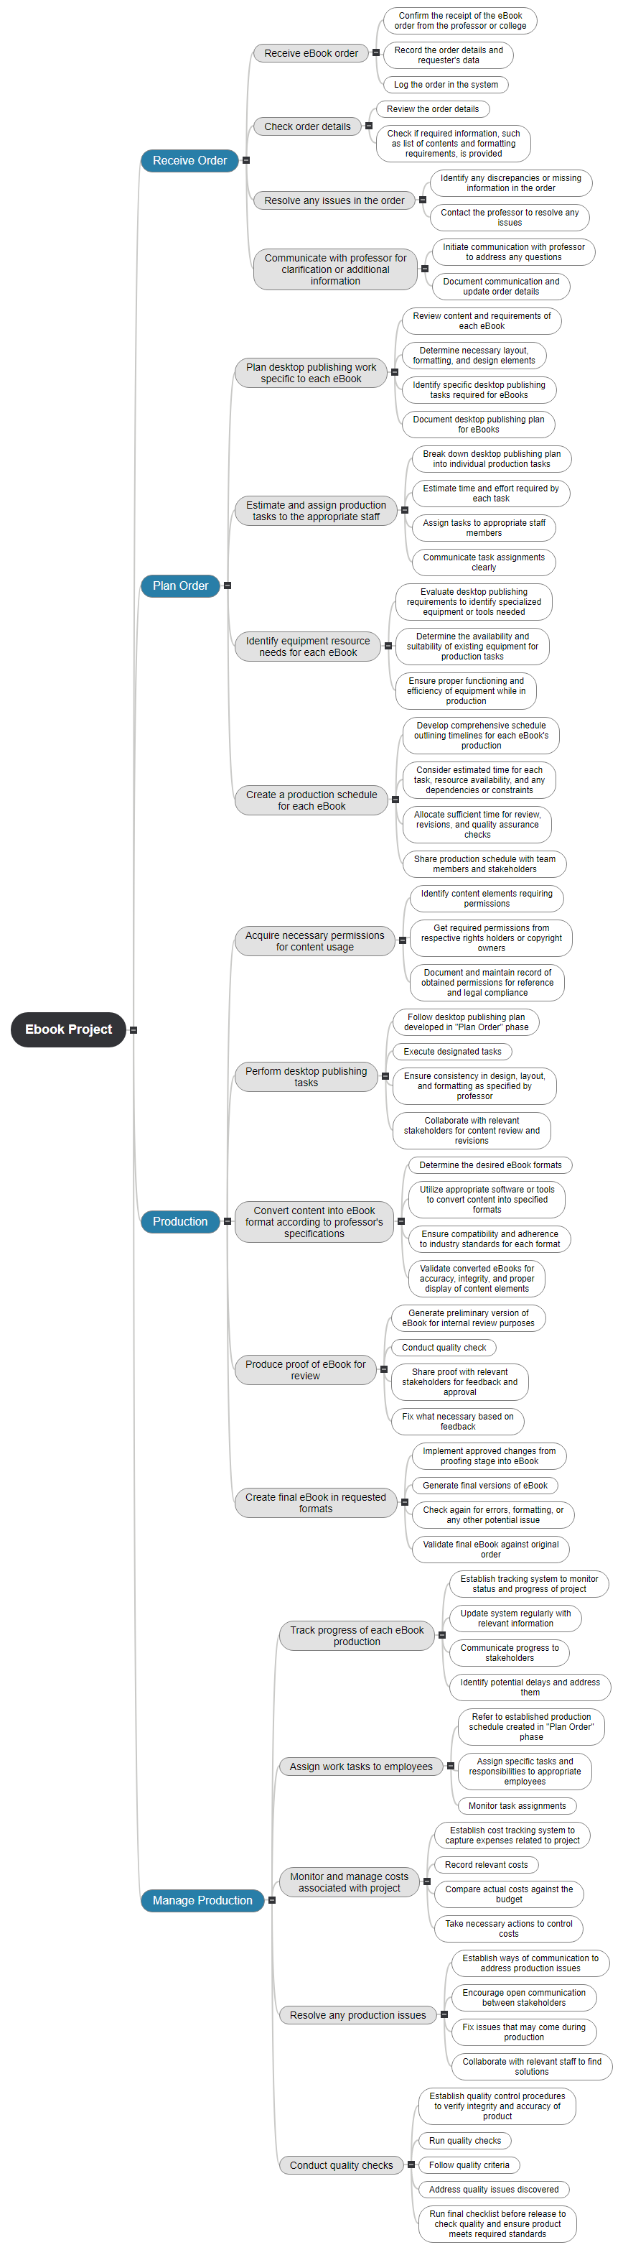

# Receive Order

## Receive eBook order

### Confirm the receipt of the eBook order from the professor or college

### Record the order details and requester's data

### Log the order in the system

## Check order details

### Review the order details

### Check if required information, such as list of contents and formatting requirements, is provided

## Resolve any issues in the order

### Identify any discrepancies or missing information in the order

### Contact the professor to resolve any issues

## Communicate with professor for clarification or additional information

### Initiate communication with professor to address any questions

### Document communication and update order details

# Plan Order

## Plan desktop publishing work specific to each eBook

### Review content and requirements of each eBook

### Determine necessary layout, formatting, and design elements

### Identify specific desktop publishing tasks required for eBooks

### Document desktop publishing plan for eBooks

## Estimate and assign production tasks to the appropriate staff

### Break down desktop publishing plan into individual production tasks

### Estimate time and effort required by each task

### Assign tasks to appropriate staff members

### Communicate task assignments clearly

## Identify equipment resource needs for each eBook

### Evaluate desktop publishing requirements to identify specialized equipment or tools needed

### Determine the availability and suitability of existing equipment for production tasks

### Ensure proper functioning and efficiency of equipment while in production

## Create a production schedule for each eBook

### Develop comprehensive schedule outlining timelines for each eBook's production

### Consider estimated time for each task, resource availability, and any dependencies or constraints

### Allocate sufficient time for review, revisions, and quality assurance checks

### Share production schedule with team members and stakeholders

# Production

## Acquire necessary permissions for content usage

### Identify content elements requiring permissions

### Get required permissions from respective rights holders or copyright owners

### Document and maintain record of obtained permissions for reference and legal compliance

## Perform desktop publishing tasks

### Follow desktop publishing plan developed in "Plan Order" phase

### Execute designated tasks

### Ensure consistency in design, layout, and formatting as specified by professor

### Collaborate with relevant stakeholders for content review and revisions

## Convert content into eBook format according to professor's specifications

### Determine the desired eBook formats

### Utilize appropriate software or tools to convert content into specified formats

### Ensure compatibility and adherence to industry standards for each format

### Validate converted eBooks for accuracy, integrity, and proper display of content elements

## Produce proof of eBook for review

### Generate preliminary version of eBook for internal review purposes

### Conduct quality check

### Share proof with relevant stakeholders for feedback and approval

### Fix what necessary based on feedback

## Create final eBook in requested formats

### Implement approved changes from proofing stage into eBook

### Generate final versions of eBook

### Check again for errors, formatting, or any other potential issue

### Validate final eBook against original order

# Manage Production

## Track progress of each eBook production

### Establish tracking system to monitor status and progress of project

### Update system regularly with relevant information

### Communicate progress to stakeholders

### Identify potential delays and address them

## Assign work tasks to employees

### Refer to established production schedule created in "Plan Order" phase

### Assign specific tasks and responsibilities to appropriate employees

### Monitor task assignments

## Monitor and manage costs associated with project

### Establish cost tracking system to capture expenses related to project

### Record relevant costs

### Compare actual costs against the budget

### Take necessary actions to control costs

## Resolve any production issues

### Establish ways of communication to address production issues

### Encourage open communication between stakeholders

### Fix issues that may come during production

### Collaborate with relevant staff to find solutions

## Conduct quality checks

### Establish quality control procedures to verify integrity and accuracy of product

### Run quality checks

### Follow quality criteria

### Address quality issues discovered

### Run final checklist before release to check quality and ensure product meets required standards